Art and Design Study Guide

The elements and principles of design are the building blocks used to create all works of art.

The Elements of Design
The Elements of Design are what artists use to create their works of art.

- Line – A path traced by a moving point. Lines can be:

  - Actual – lines are physically drawn or painted.
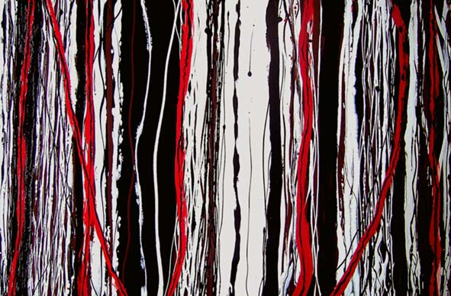

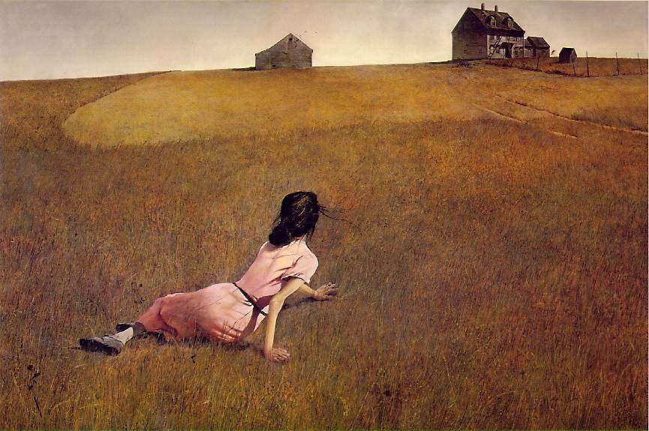
  - Implied – no physical line is created, but the viewer’s eye follows a specific path
From the woman to the house in this painting ⇒

- Shape – A two-dimensional enclosed area. Shapes can be…

  - Geometric – regular, predictable, found in the constructed world
  - Organic – irregular, unpredictable, found in nature

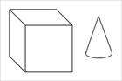
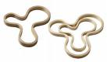

- Value – The degree of darkness or lightness in a work of art.
  - High values are light.
  - Low values are dark.

- Color – An element of design that can be defined by its three properties - hue, value, and saturation.

- Texture – The surface appearance in a work of art. Textures can be…
  - Actual, meaning they can physically be felt, such as those found on a smooth sculpture or bumpy painting.
  - Illusional, where the artwork portrays the illusion of a texture that can’t actually be felt.

- Form – The three-dimensional volume in a work of art. Form can be:

  - Actual, as in a 3-D sculpture
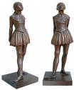

- Illusional, as in a shaded drawing that looks 3-D, but is actually flat.
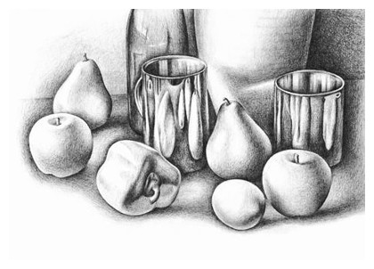

- Space – The area within or around an object in a work of art.
  - Positive Space – enclosed space that is distinguished from the background. (The white sections in the image below.)
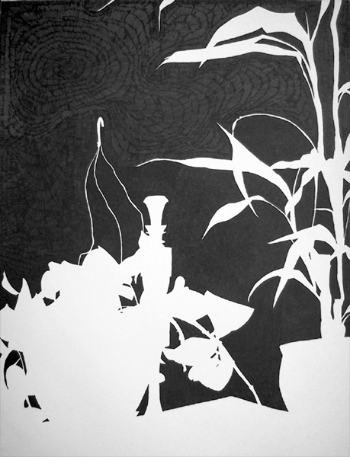
  - Negative Space – empty space that makes an essential contribution to the composition. (The black sections in the image below.)

The Principles of Design
The Principles of Design refer to how artists use the elements of design to create their compositions.

- Balance – The visual equalization of the elements of design. Balance can be:

  - Symmetrical – visually the same (or very similar) on both sides, if divided in half
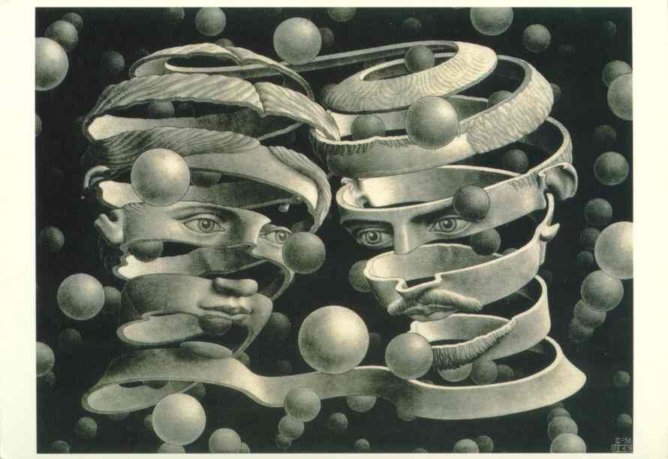
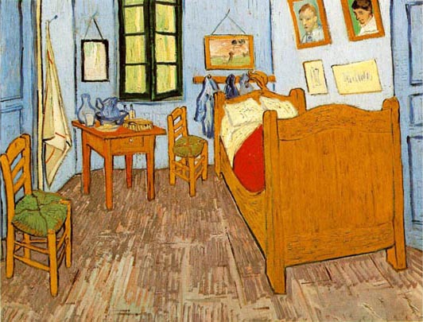
  - Asymmetrical – visually different if divided in half, but still balanced

- Contrast – Strong differences in the elements in order to create emphasis and visual interest. Contrast can be created with any element of design, such as:
  - Value (ie. black next to white)
  - Color (complementary colors, like blue and orange, next to each other)
  - Texture (rough next to smooth)
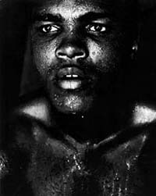

- Emphasis – The use of the elements of art to stress or give importance to a component in a work of art. Another term for Emphasis is Focal Point. Emphasis is often created through strong contrast.

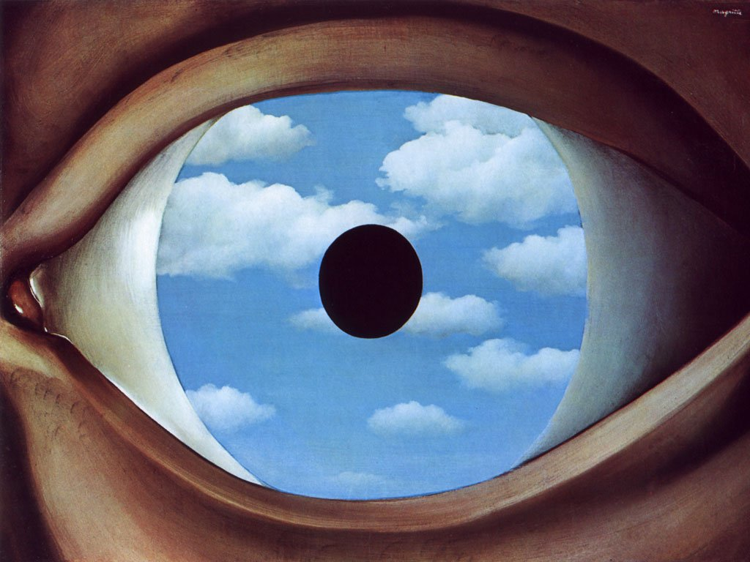

- Movement/Rhythm – The arrangement of the elements of design to draw the viewer’s eye through the work of art.
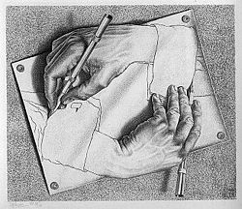
From pen to hand to wrist, to pen to hand to wrist, etc.

- Unity – A sense of wholeness that results from the successful combination of the elements of art. Unity can be created through the use of a consistent texture, color scheme, or a repeated shape.
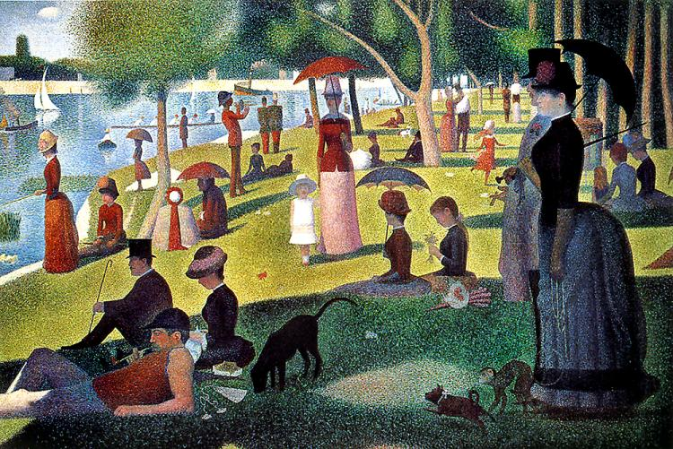

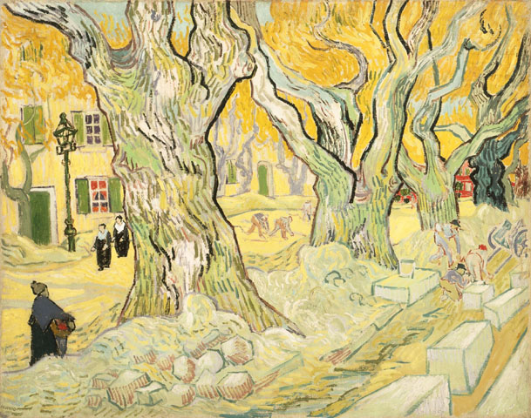
- Proportion – The size relationships within a work or art. Artists use realistic proportions to help create a sense of depth.

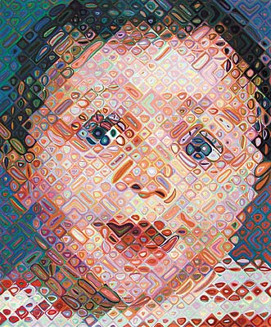
- Variety – Slight changes of a certain element, such as shape or color, to create visual interest in a work of art.

Color Vocabulary

Hue: the property of a color that distinguishes one gradation from another and gives it its name (red, blue-green, etc.)

Value: the lightness or darkness of a color; the amount of black or white in a color; dark colors have a low value and light colors have a high value

Intensity: the degree of purity or saturation of a color; high intensity colors are brighter (ex. emerald green) and low intensity colors are duller (ex. army green)

Primary Colors: colors that cannot be made by mixing other colors – red, yellow, and blue

Secondary Colors: colors that are made by mixing the primary colors – orange, green, and purple

Tertiary Colors: colors that are made by mixing two analogous colors – red-orange, orange-yellow, yellow-green, green-blue, blue-violet, violet-red

Analogous Colors: colors that are next to each other in the color wheel which have a base color in common (ex. green, green-blue, and blue or red, red-violet, and violet)

Complementary Colors: colors that are on opposite sides of the color wheel; when mixed together they dull each other; when placed next to each other they create the most contrast; red and green; yellow and violet; orange and blue

Monochromatic Color Scheme: a color scheme that includes one color plus tints and shades of that color.

Warm Colors: those colors of the spectrum that suggest warmth, including red, orange, and yellow; warm colors usually seem to advance when used with cool colors

Cool Colors: those colors in the spectrum that suggest coolness, such as green, blue, and violet; cool colors usually seem to recede when used with warm colors

Tint: a color plus white

Shade: a color plus black

Tone: a color plus gray

